Big Mountain Resort Ticket Profitability

In Montana Big Mountain Resort’s executive board suspects that they are not maximizing their profitability in the current ticket prices ($81.00/ticket) they have set. Part of the issue is that they are unsure of which of their facilities attracts the most visitors. A predictive pricing model is needed to determine whether Big Mountain’s ticket prices are competitive for what they can provide; and identify which aspects of the resort to invest in more to maximize profits.

Data from 330 United States ski resorts were aggregated for analysis across 27 characteristics. Since pricing is the main purpose of this predictive model, any resort missing pricing data was immediately dropped. For this model, weekend pricing was the primary metric due to information availability. After removing the rows with too much missing data and irrelevant columns, 277 resorts remained across 25 characteristics. The data was then further refined to standardize population and size metrics and add the proportions of skiable area, days open, terrain, and night skiing available.

Using a random forest regressor, Big Mountain Resort may be undercharging their visitors despite ranking in the top 20% of ticket prices of resorts that were surveyed (Fig. 1).

Figure 1. Adult weekend ticket prices of 277 resorts.

Based on how the market charges for their facilities, Big Mountain’s weekend pricing should range from $85.48 to $106.26. The key factors contributing to this estimate include the longest vertical drop, number of runs, area covered by artificial snow, and number of fast quads (Fig. 2).

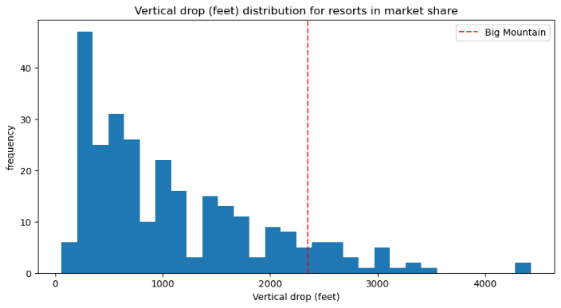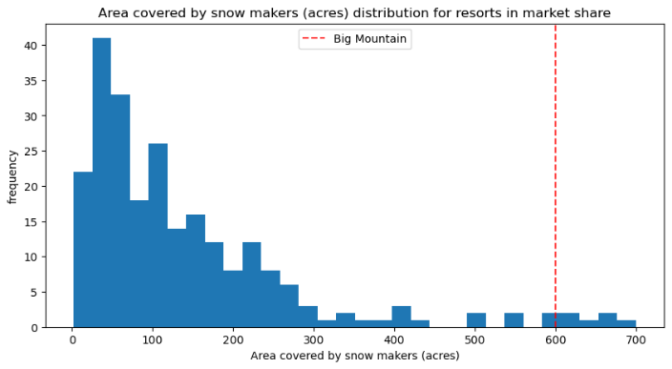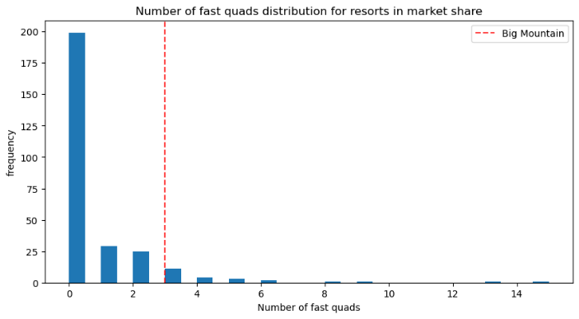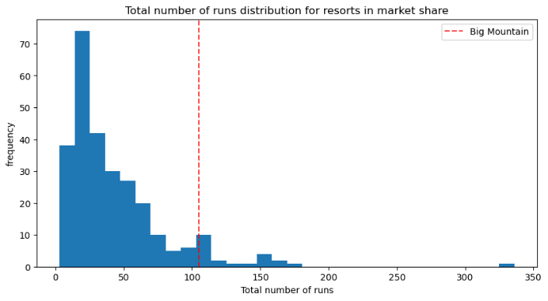

Figure 2. Distribution of feature metrics for vertical drops, number of runs, area of artificial snow, and number of fast quads across the market. Big Mountain Resort's position is highlighted in all graphs by a vertical red line.

To maximize profitability, Big Mountain should at least raise its prices within the expected range. Additional revenue could be generated over the next season if the resort invests in adding a run that extends down by 150 feet and adding a new chair lift. Investing in these new features would justify a ticket price increase of $1.99. These changes could result in $3,474,638 additional revenue if the resort accommodates 350,000 visitors who stay for at least 5 days.

Based on the available facilities and upgrade potential, Big Mountain Resort has options to increase its prices within a more competitive margin. Moving forward, additional information like operation and installation costs and individual facility usage would be useful to create a more considerate model of facility profitability.